**Tables – Revision_Activity**

On a new document, create the basic table (with 5 columns and 4 rows) as shown below:

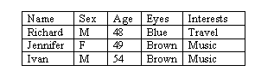

*You may need to change the column widths.*

Add your own details at the end of the table (press TAB key to insert an extra line at the end of the table).

This activity can be completed after the Lesson has been taught ( Lesson 5)

Change the border lines, shading and row height to create a table similar to the example shown below:

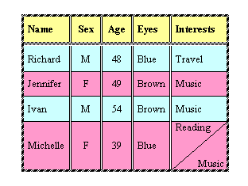

*Press ENTER to add "Music" below the diagonal line.*

Save the document with the name:      **Client overview details**and then close it.